**Read Me s3584767 Chang Cheng**

**s3622466 Tianyi Li**

This program is implemented by Eclipse, also all the data is saved in the database.

After loading this solution into Eclipse, you will be able to click the Run button on the top right corner.

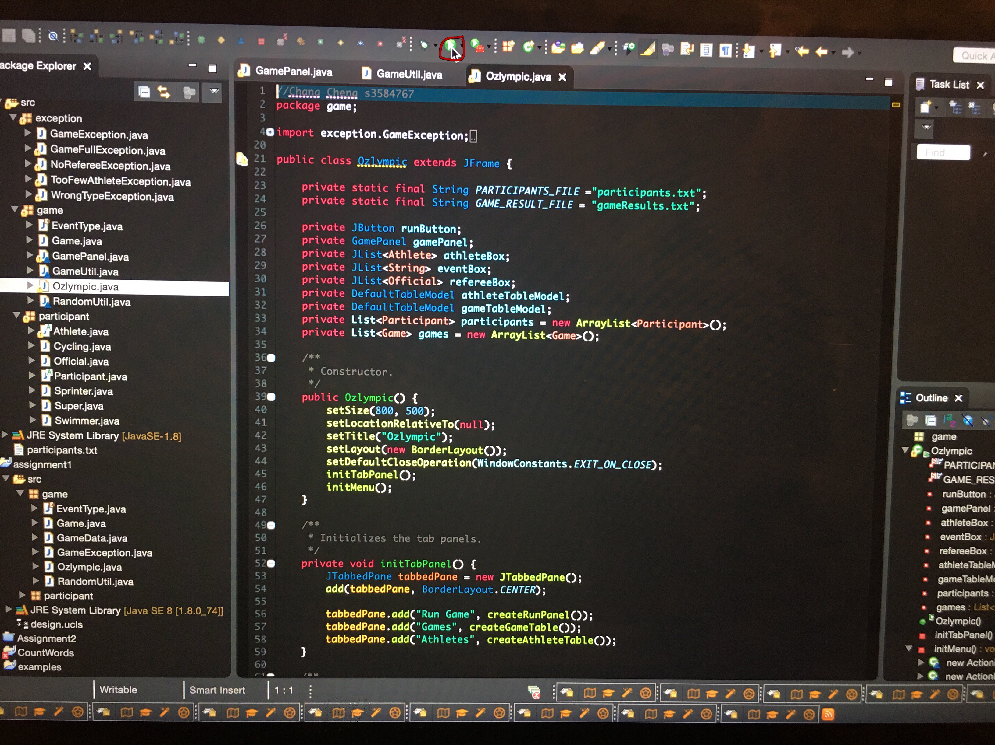

Click the button, the program will start running.

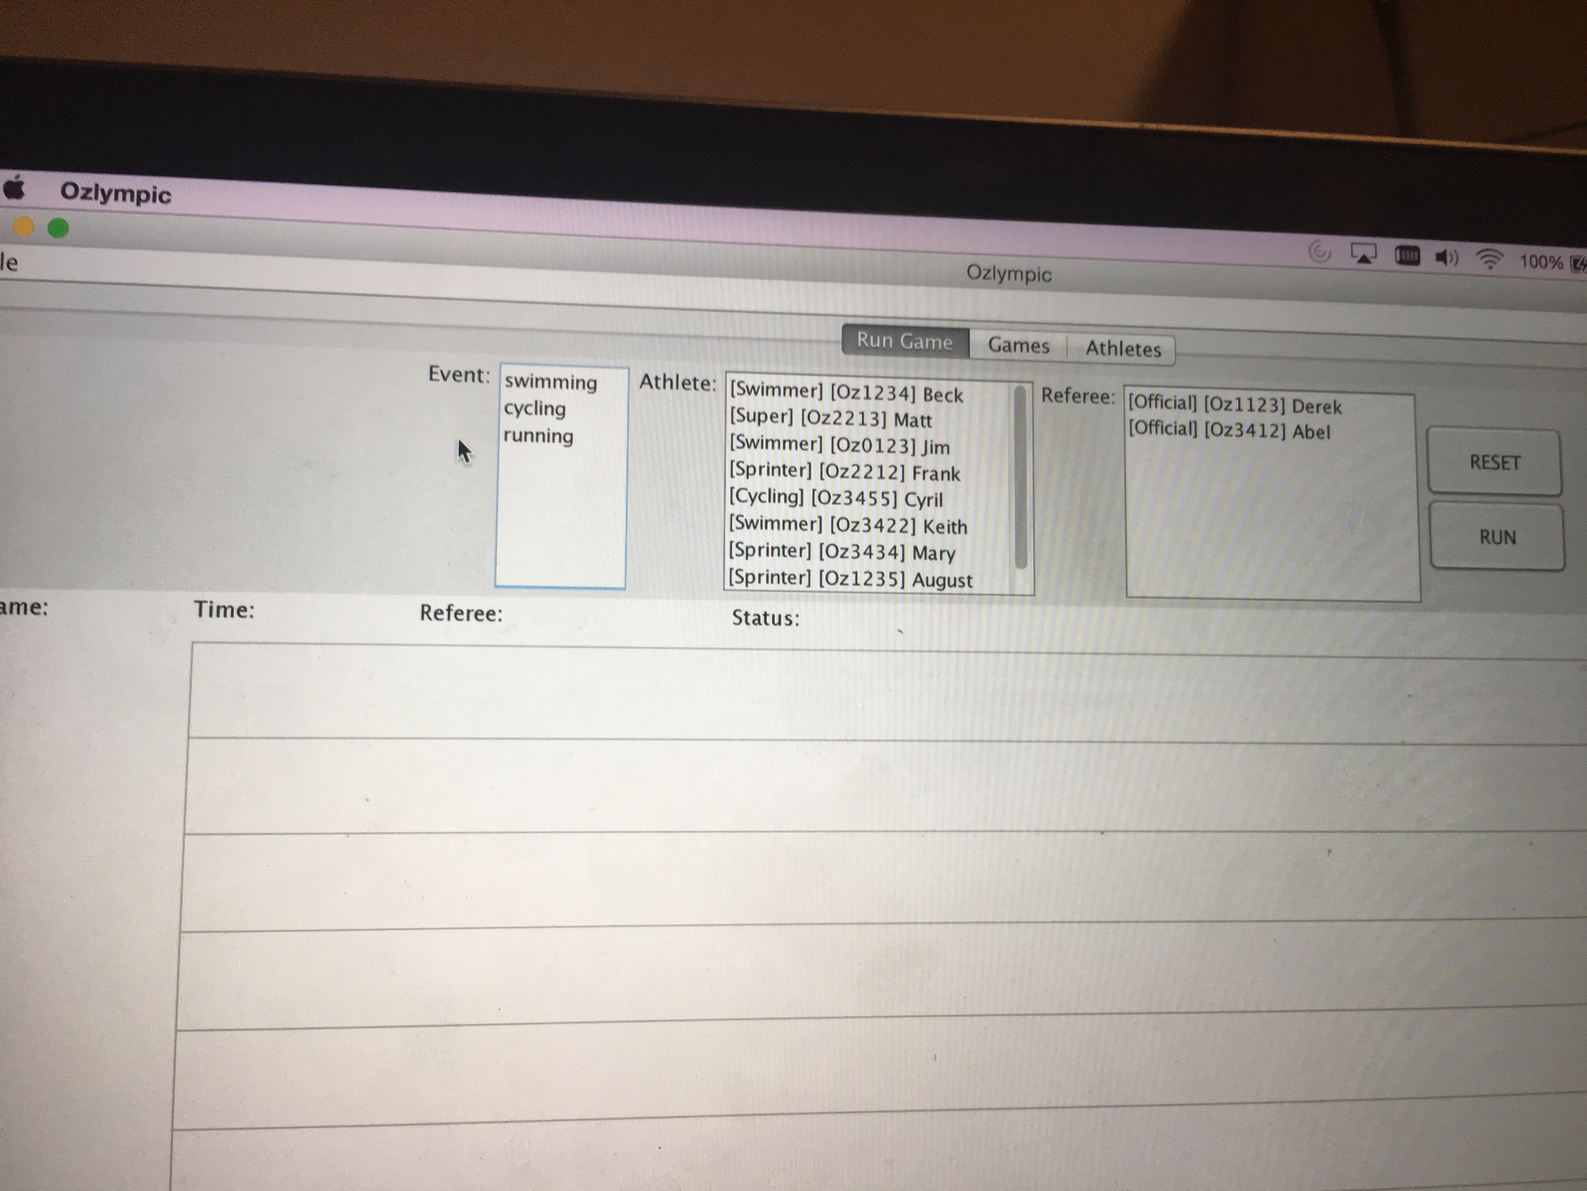

1. Select the *Event*

This pane allow you to choose an event.

1. Select four Athlete

Also the system will check whether you choose right athlete and no less than 4 athletes

1. Select one Referee
2. Click Run button

After click the Run button on the top right, the competition function will start.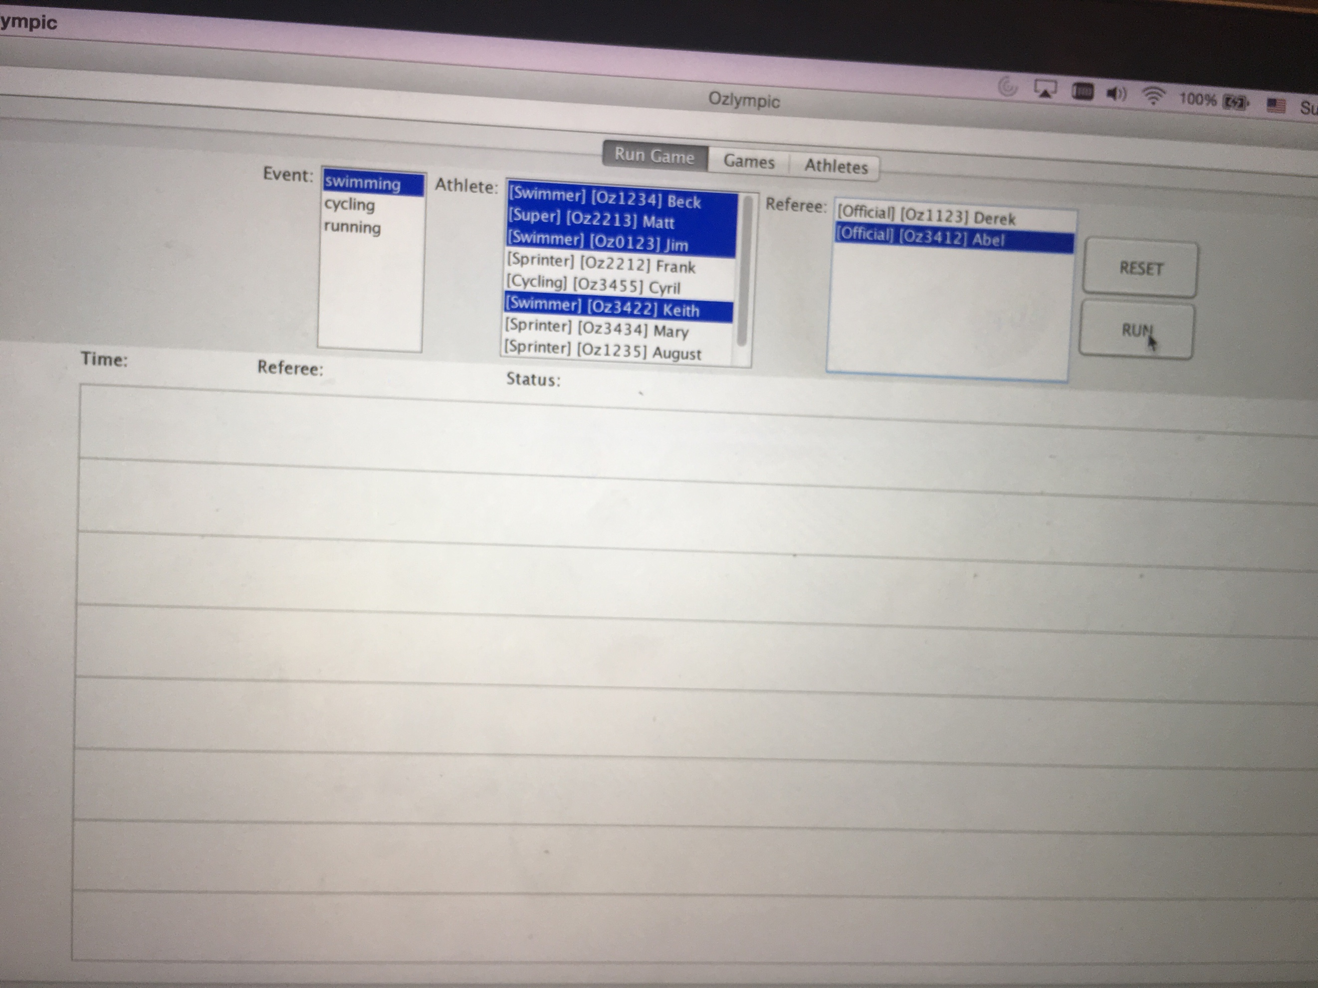

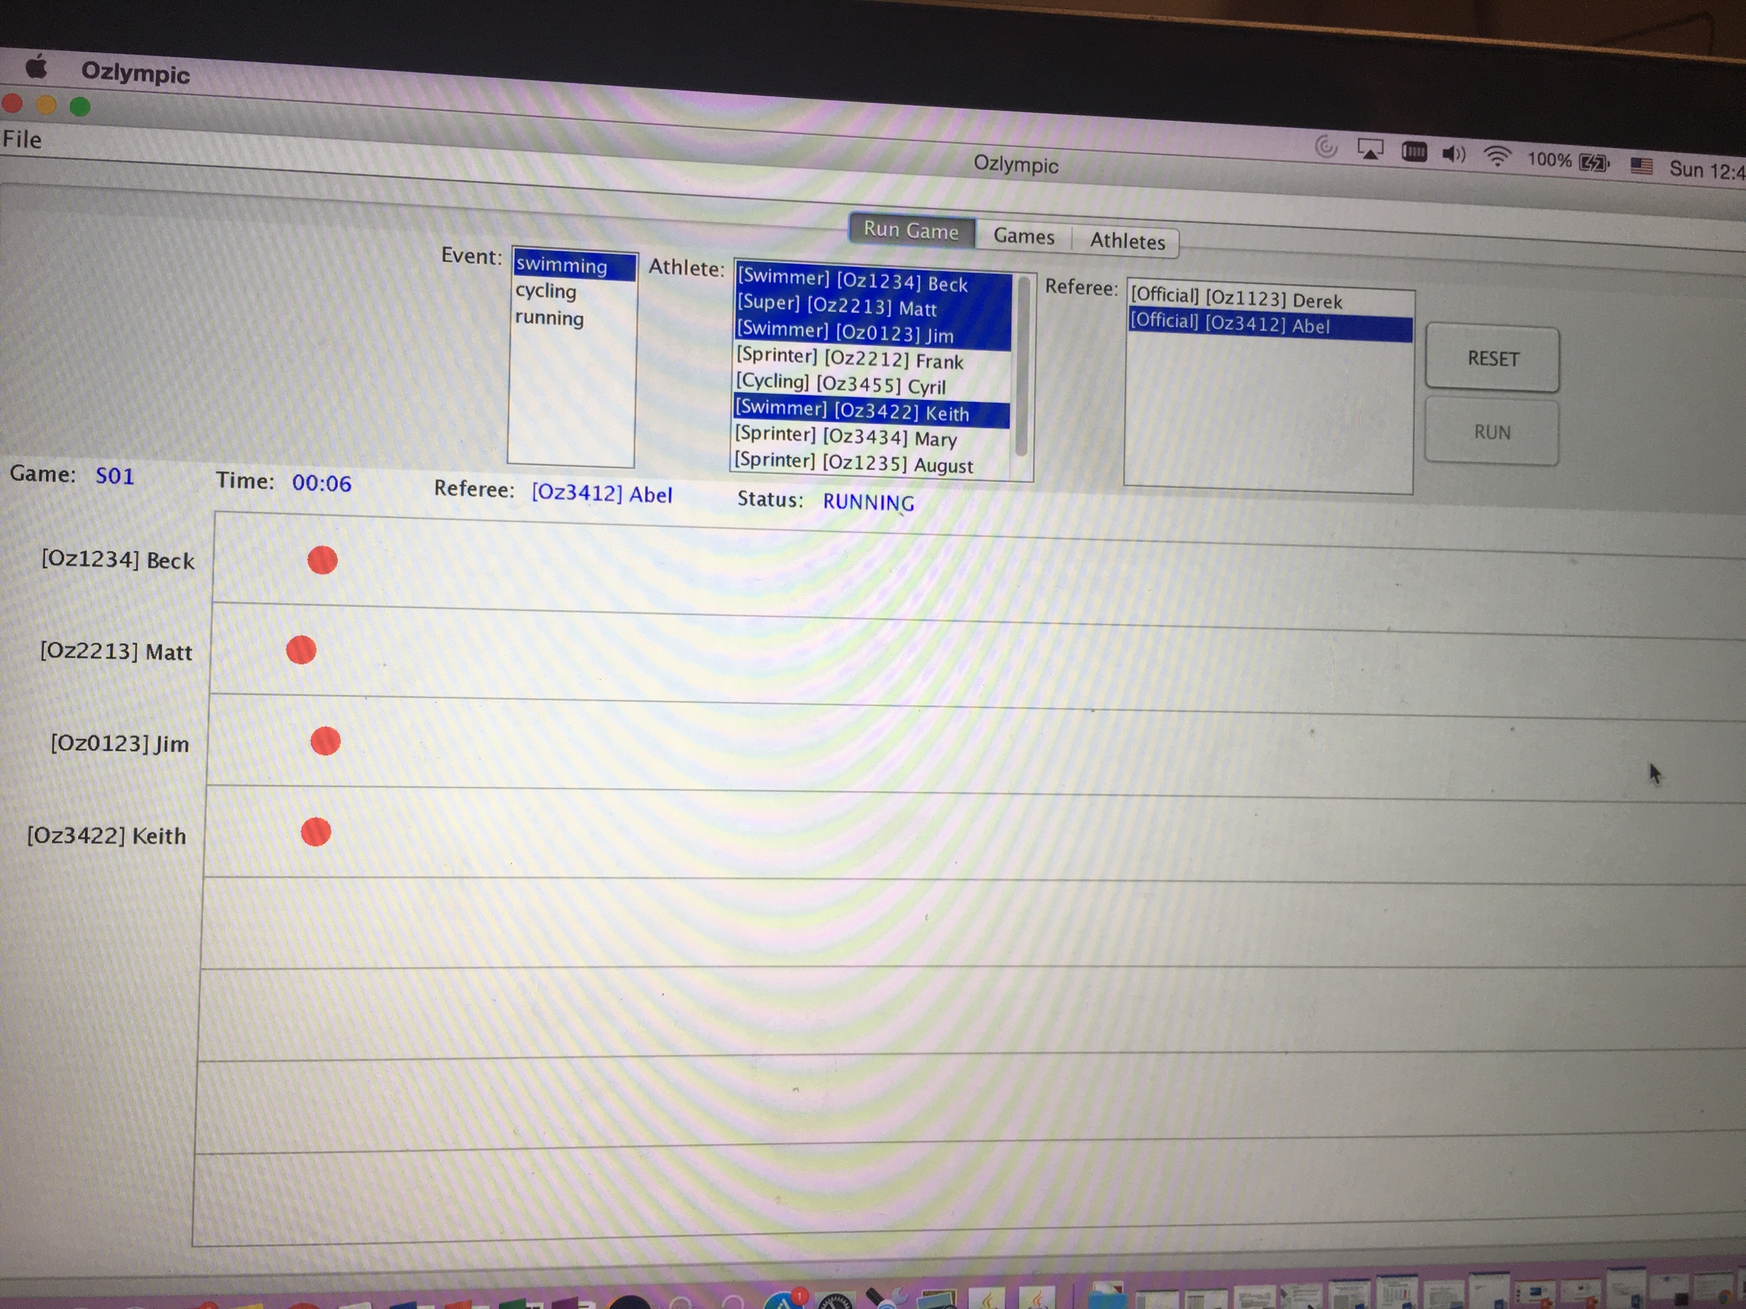

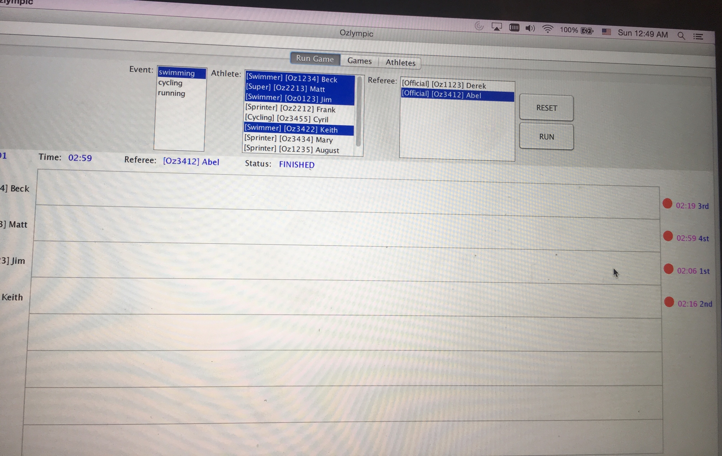

after click the save game results tag on the File button.

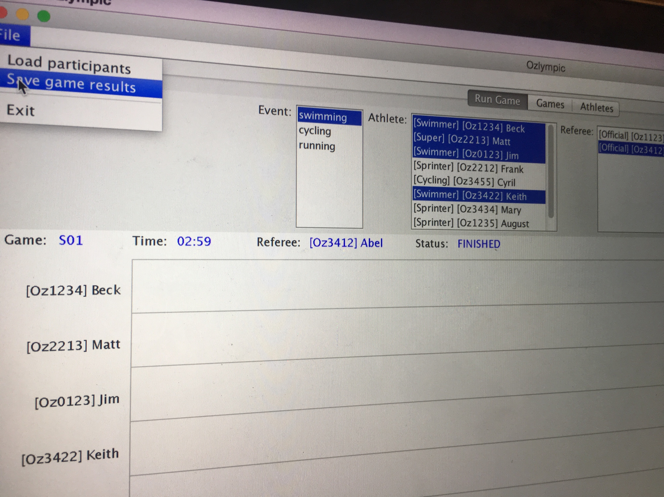

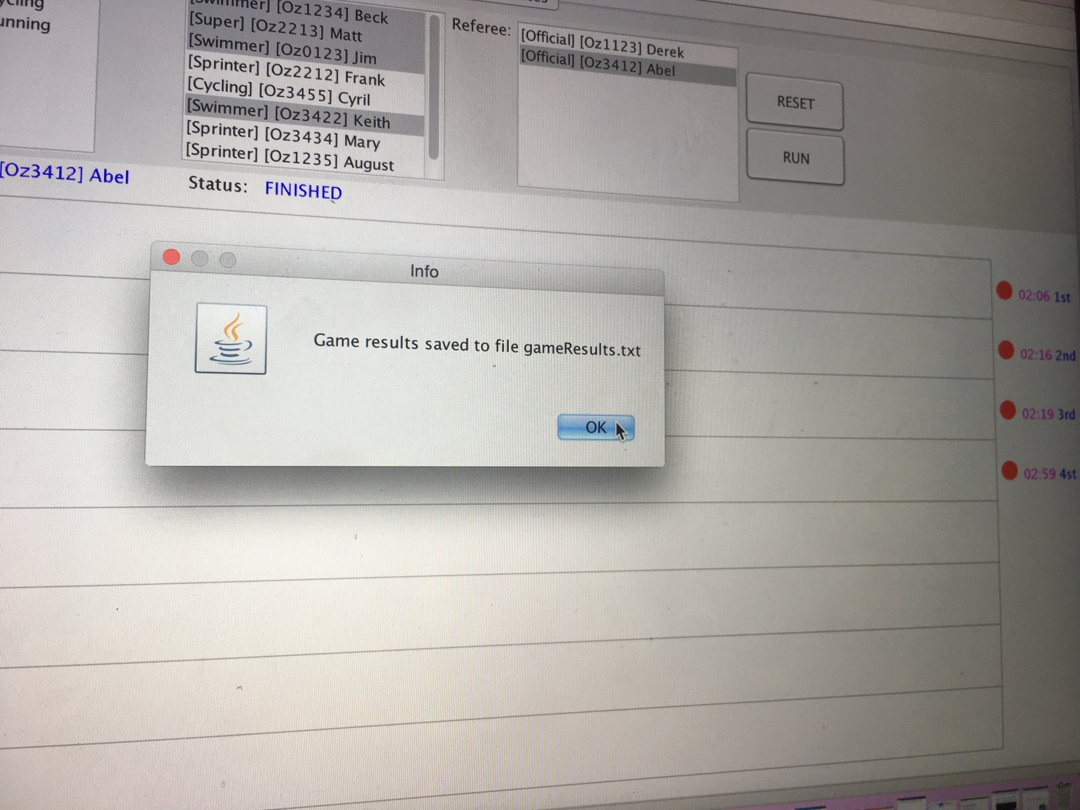

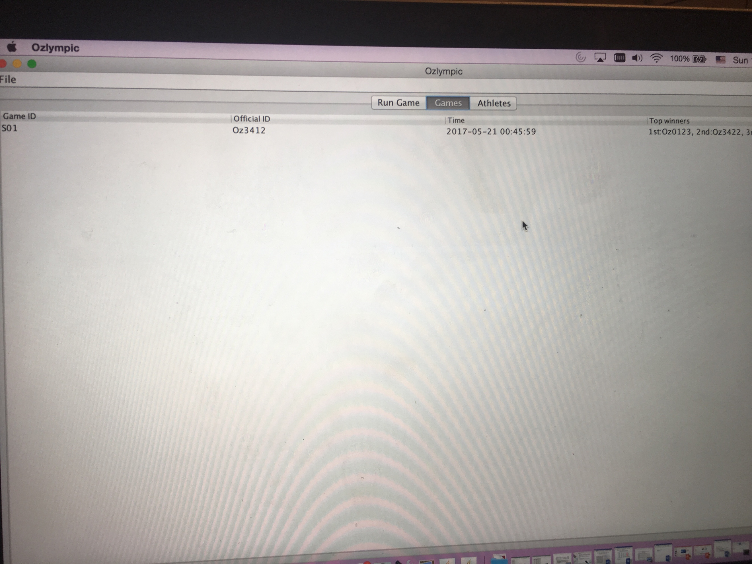

Our group assigned assignment 2 for 50:50 split of coding between us. Chang Cheng response for Olympic, Exception and Readme file part, the other Tianyi Li responses for Game panel and game util part. We learned a lot from this assignment about GUI and have already practiced.